Drawing tools

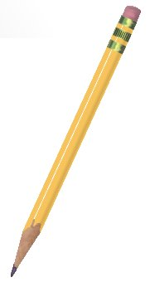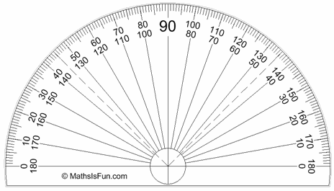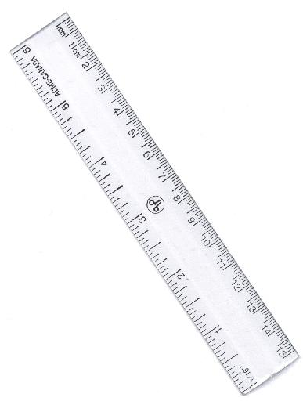

Lily buys a pencil and two rulers. She pays 60p.

Charlie buys three pencils. He pays 72p.

James buys a pencil, a ruler and a protractor. He pays 57p.

How much would Lydia pay for two pencils and a protractor?

